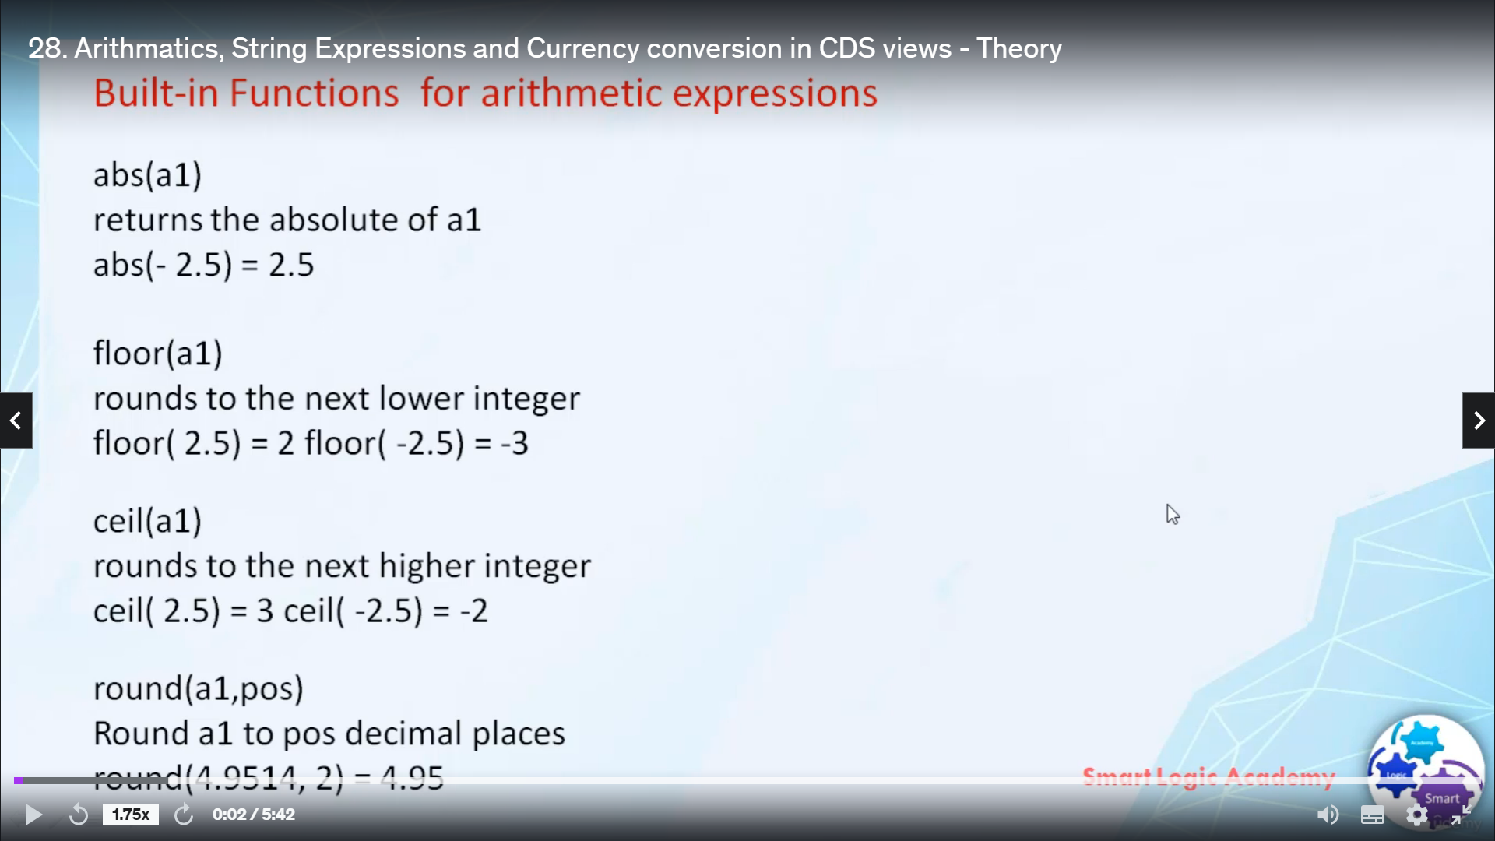

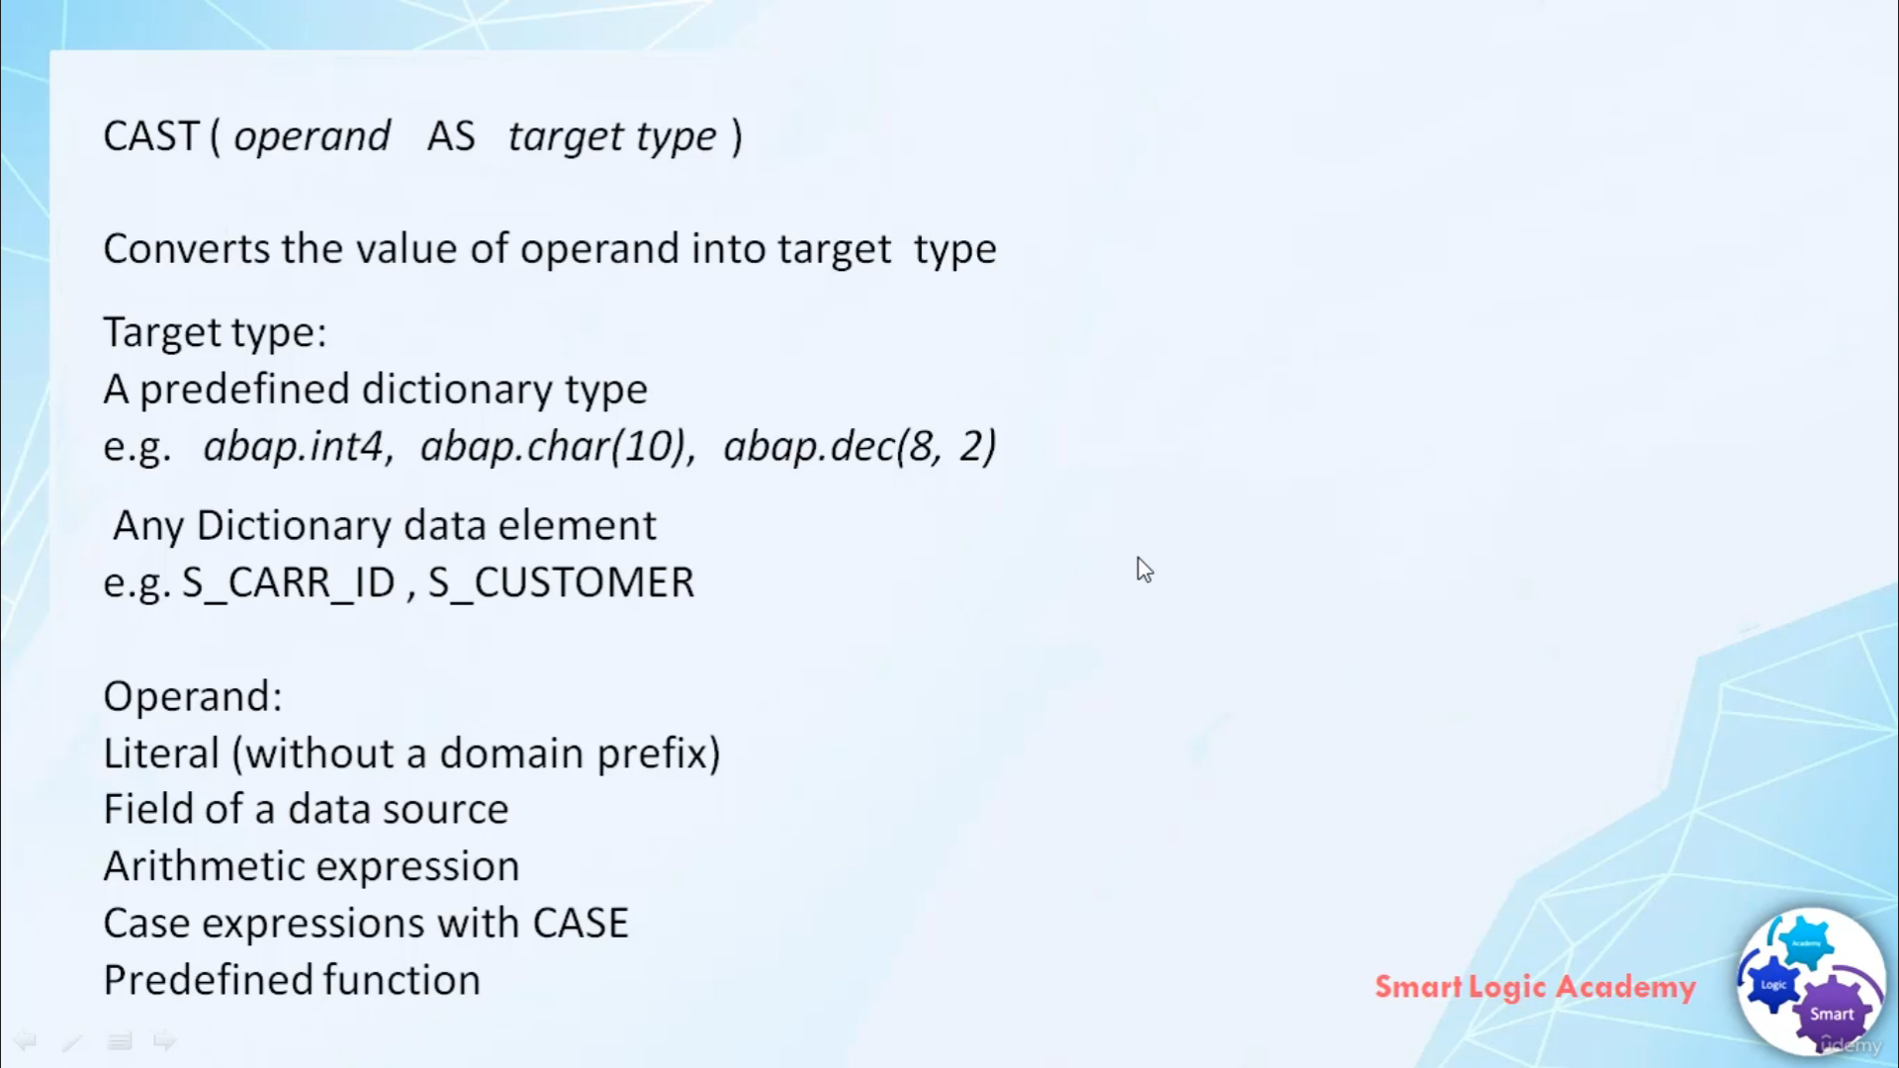

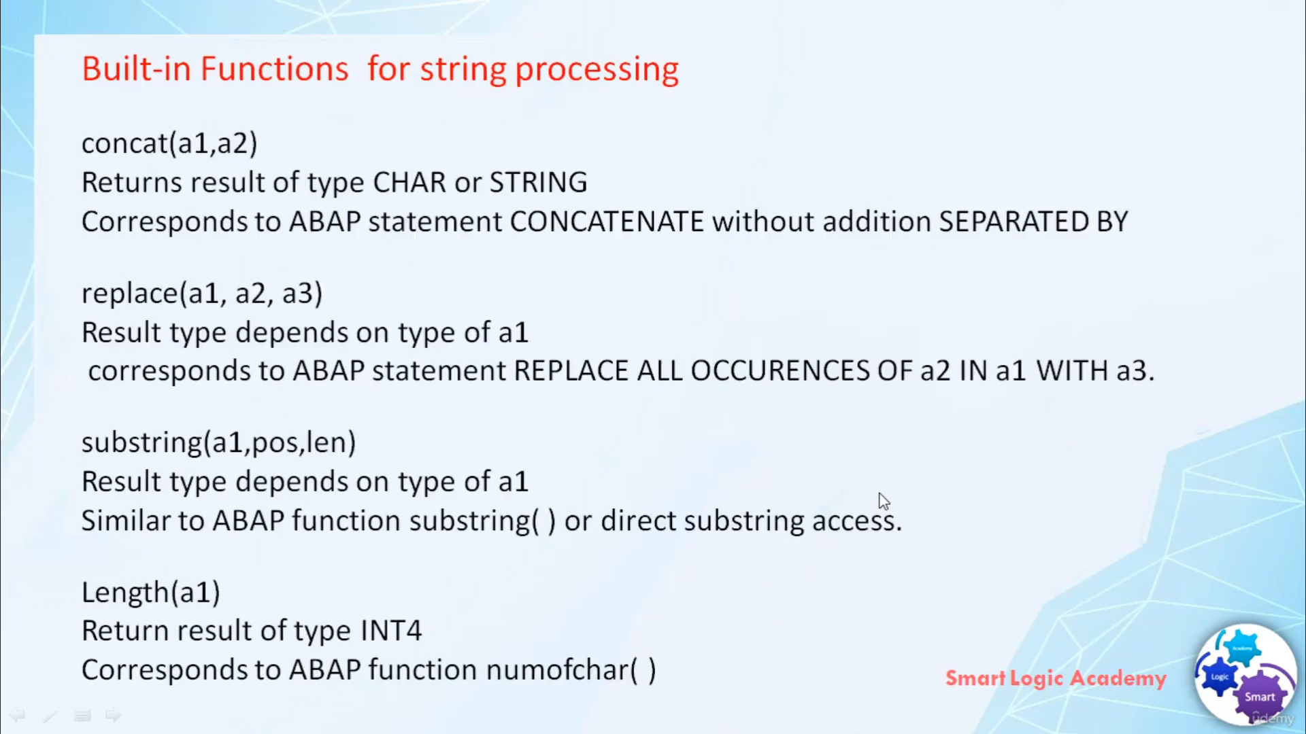

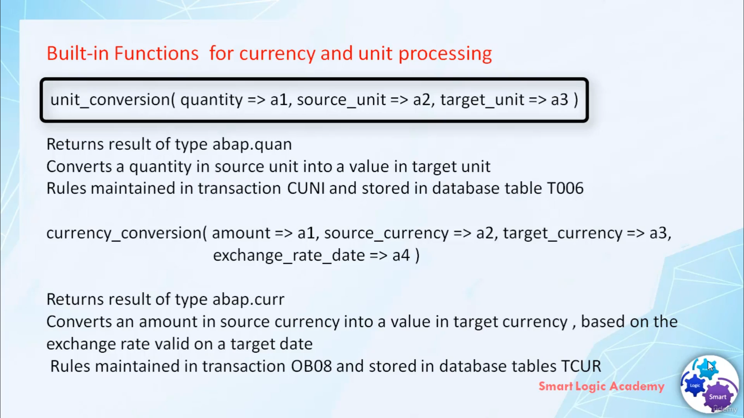

Hi, welcome back.

In this video, I will discuss with you about arithmetic, explosions and string explosions in Chordata

services.

So let's stop in our studios, arithmetic expressions can be used as elements of frailest.

I'm absolutely supports many expressions, such as addition, subtraction, multiplication and division.

It also supports some built-In functions, such as Abes Floor Cell and from.

Have information about it returns absolute value of argument, for example, abuse of minors to qualify

will result in two 2.5 million fortune it around.

Our next lowering digital from, for example, to polyfoam will translate into boom and flow.

Minus two point five will descend into minus three.

Built in functions, phones be augmented next high integer, for example, say two point five equals

good three and say minus 2.5 will result in two, minus two.

Building for children takes to argument as they put this building function rounds, first argument,

a number of decimal places given by second argument, for example, around four point nine five one

four come to this will limit first argument to only two decimal places.

So the result is four point nine five.

Unlike a map of Webster, this doesn't know implicit conversions, hence we need to use building function

cost degassed expression of this allows you to implement explicit conversions built in function caused

to augment as input.

First argument is open and the second one is targeting.

This building function converts the value of operand into target type disvalue supported by Allburn.

Or it can be literal full of energy.

Tussaud It can be a diplomatic expression or expression, but also can be predefine function.

That type can be a predefined dictionary, such as either by default or it can be any additional details

such as X.

And of course Scott underscore idee or isn't as good customer.

Absolutely supports sting operations.

Here are some great inventions in our Web series that we use for string processing.

The first building function is concat.

It used to concatenate two strings.

It correspond to a better segment, concatenate without additions, separated by.

Building replace place three argument rising food, Avenir 23, it corresponds to above statement,

a place all appearance of a do in heaven with a three.

Turtleback, the information is substring.

Bakhtin Fajon Substring is very much similar to you about function substring building function substring

result out substring from argument even based on Borjigin and linked building function land is used

to find Lintott argument even.

Absolutists also support some betting functions for currency and unit processing.

To make a values in different units or currencies compatible with each other, they need to be converted

within function, unit conversion, conversion, quantity in source unit into value in target unit.

This building function returns a result of type of abdul-karim quantity.

We didn't mention currency conversion, a conversion amount in source currency into value and target

currency based on the exchange rate we valued on target date, this building conversion function returns

a result of type I don't see you a currency.

No, I hope you know what different arithmetic and string expressions supported by Abyssinians.